To provide access-RDP

11 December 2023

17:11

If in AX grp they ask to provide an access for user

Login to TS01

Windows+R ----Lurmgr

Click group , then click double click the remote desktop user

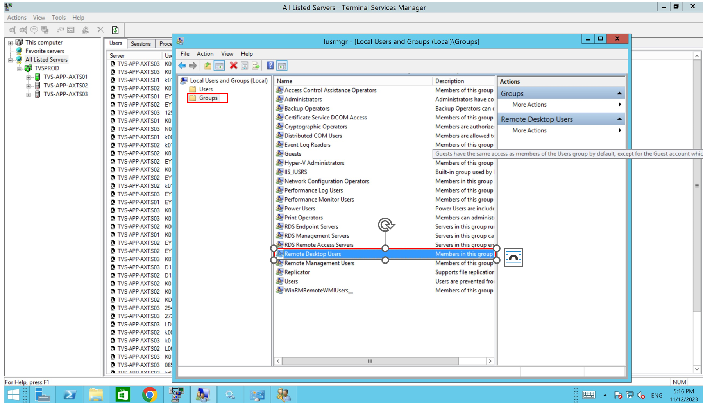

click add

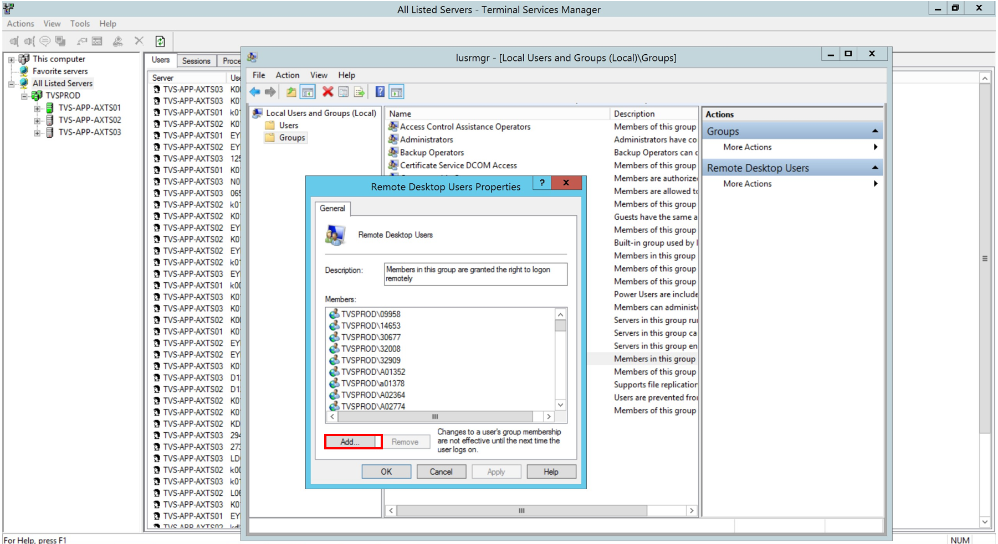

Enter the user id which they gave

Then click checkname -if any user name came ,then click apply and ok

If no username came kindly check with AX team.

